Бланк заказа коронок NuSmile

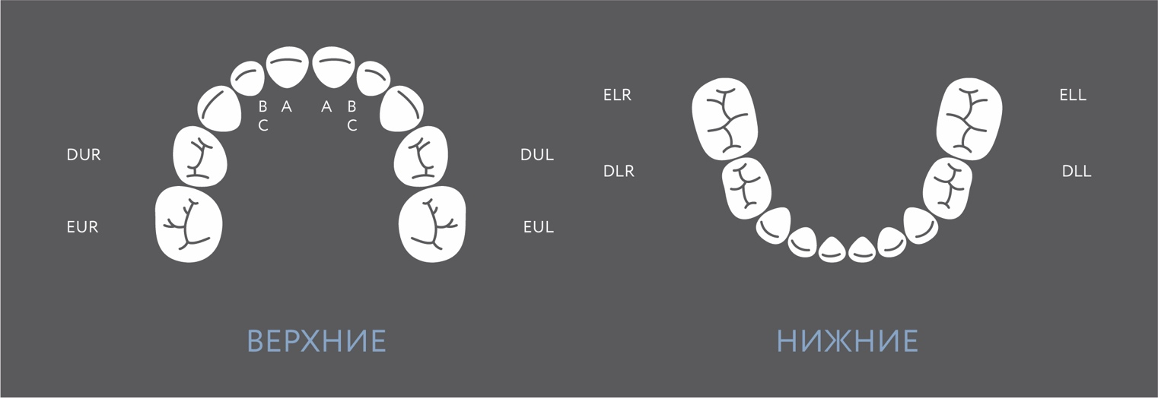

Фронтальные

А1 (51/61) | А2 (51/61) | А3 (51/61) | А4 (51/61)
B1 (52/62) | B2 (52/62) | B3 (52/62) | B4 (52/62)
C1 (53/63) | C2 (53/63) | C3 (53/63) | C4 (53/63)

Боковые

DUR2 (54) | DUR3 (54) | DUR4 (54) | DUR5 (54)
EUR2 (55) | EUR3 (55) | EUR4 (55) | EUR5 (55)
DUL2 (64) | DUL3 (64) | DUL4 (64) | DUL5 (64)
EUL2 (65) | EUL3 (65) | EUL3 (65) | EUL3 (65)
ELR2 (85) | ELR3 (85) | ELR4 (85) | ELR5 (85)
DLR2 (84) | DLR3 (84) | DLR4 (84) | DLR5 (84)
DLL2 (74) | DLL3 (74) | DLL4 (74) | DLL5 (74)
ELL2 (75) | ELL3 (75) | ELL4 (75) | ELL5 (75)

